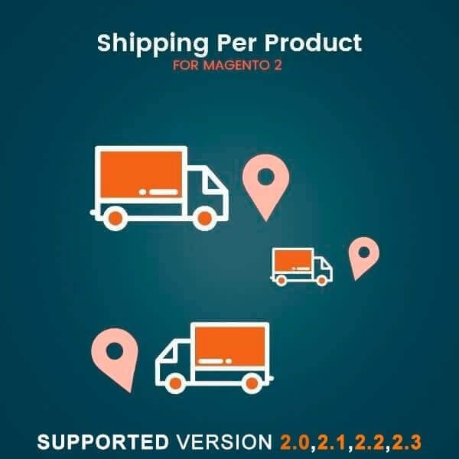

[Shipping per product – Magento 2](https://www.mageants.com/shipping-per-product-extension-for-magento-2.html)

USER MANUAL

**Table Of Contents**

Preface ............................................................….................. 3

Installation Guide ................……...………………………………. .3

Configuration...................................................................……5

FrontEnd ........................................….................................... 7

**Preface:**

With Shipping Per Product you no longer have to be worry about incorrect shipping rates for each product in your Magento store. Magento 2 Shipping Per Product Extension helps you to set individual flat shipping rate for each product. Shipping On Per Product is an essential feature for the sellers that’s why we have created an add-on for seller to add shipping price for each product from their panel.

Installation

There are two ways of installing extension in magento2.

1) Using COMMAND LINE.

2) Manually Install extension.

Option 1: Magento 2 install extension using COMMAND LINE

(Recommended)

Follow below steps to install extension from the command line.

Step 1: Download the extension and unzip it.

Step 2: Upload it to code directory in your magento installation’s app directory if

code directory does not exists then create.

Step 3: Disable the cache under System → Cache Management.

Step 4: Enter the following at the command line:

php bin/magento setup:upgrade

Step 5: Once you complete above steps logout and login back to the admin panel and switch to Store → Configuration → Sales –> Shipping method → Shipping per product , the module will be displayed in the

admin panel.

Option 2: Magento 2 install extension manually

Step 1: Download the extension and unzip it.

Step 2: Upload it to code directory in your magento installation’s app directory If code directory does not exists then create.

Step 3: Disable the cache under System -> Cache Management Edit app/etc/config.php file and add one line code:

‘Mageants_Shippingperproduct’ => 1

Step 4: Disable the cache under System -> Cache Management

Step 5: Once you complete above steps log out and log in back to the admin panel and switch to Store → Configuration → Sales –> Shipping method → Shipping per product, the module will be displayed in the admin panel.

**Configuration**

After Installation of Extension log in to Magento admin panel for set configuration of the extension and go to,

**Extension menu and sub menu.Shipping per product method**

**configuration go to Store→Configuration→Sales →Shipping**

**Methods→Shipping Per Product.**

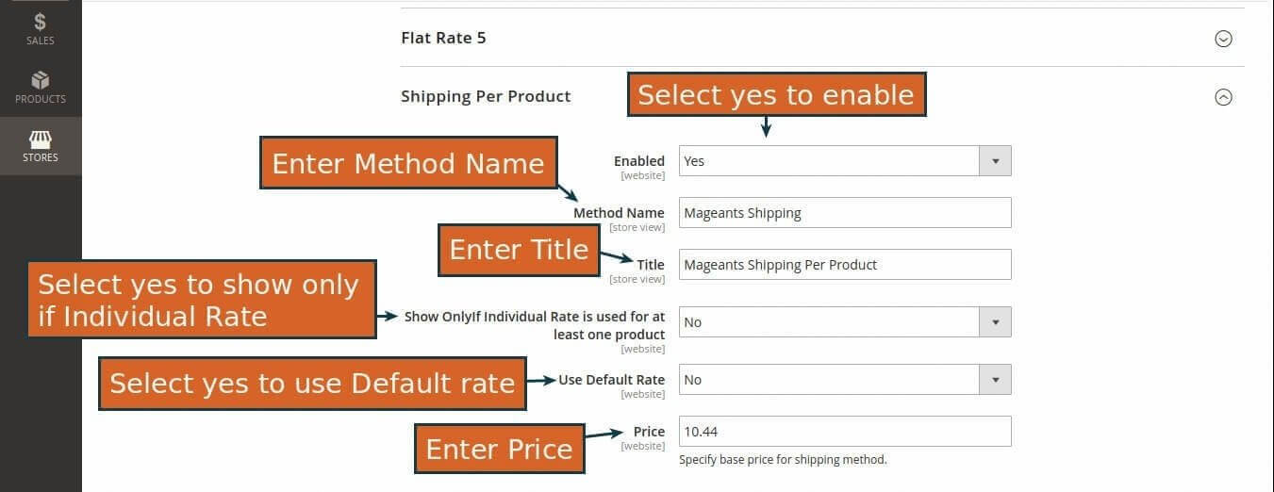

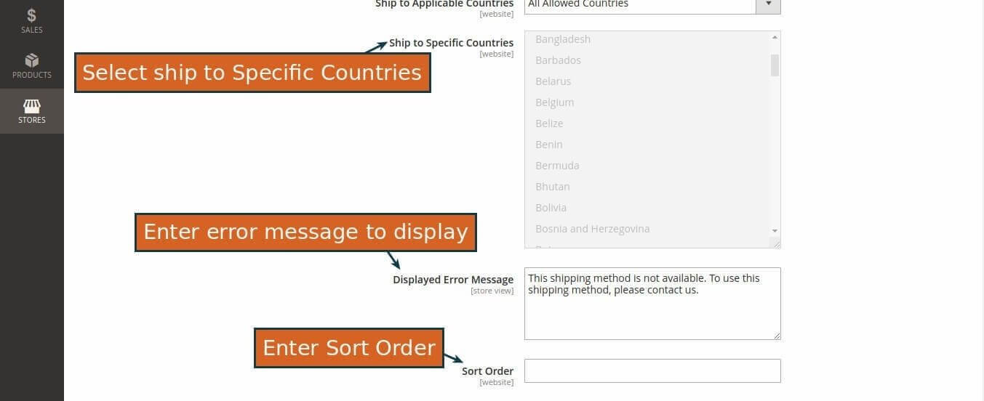

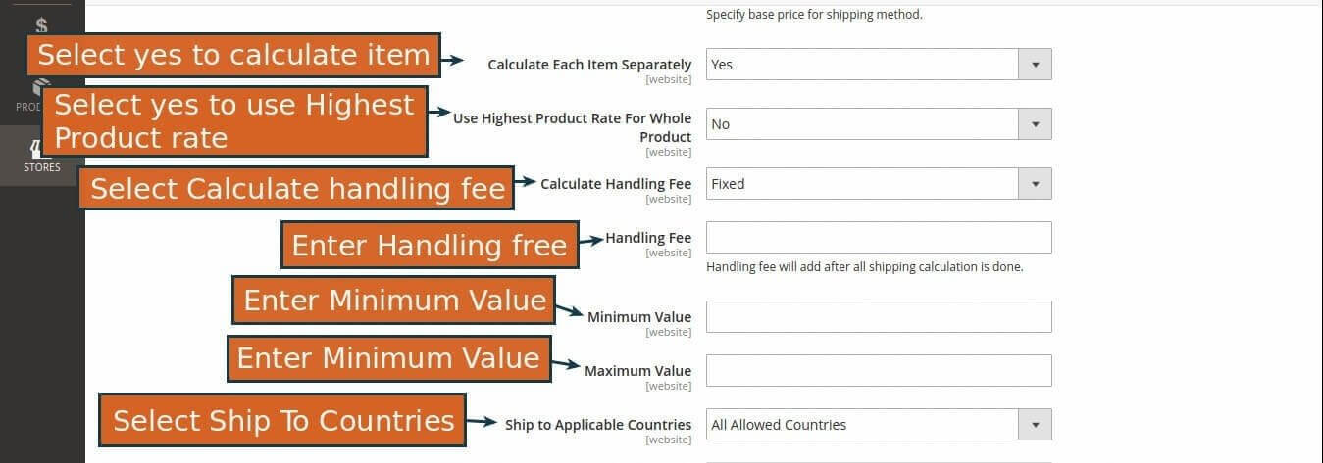

Set Shipping fee for product in product page go to Product→ Catalog then view product.

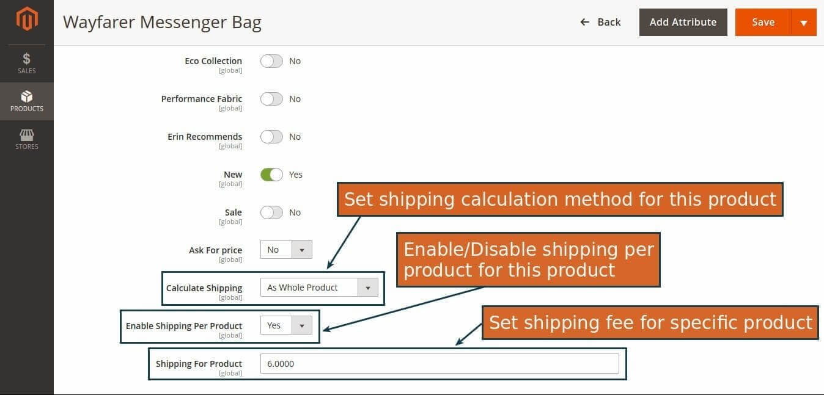

Using csv file update shipping per product price.

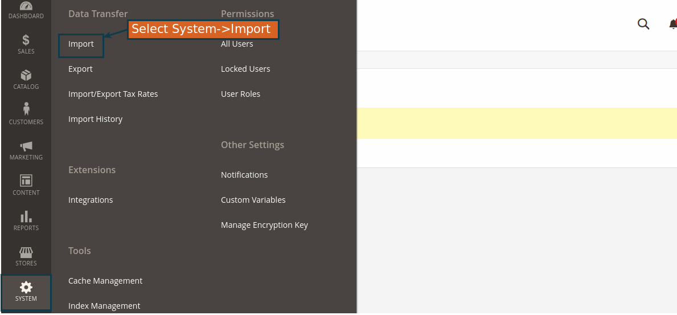

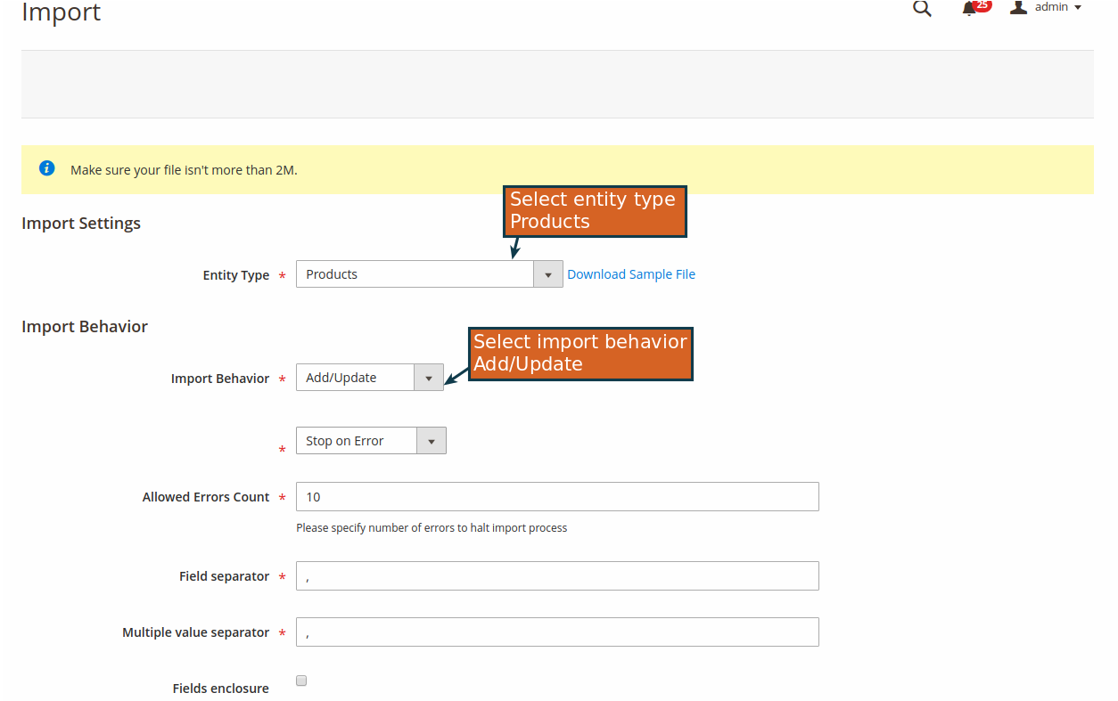

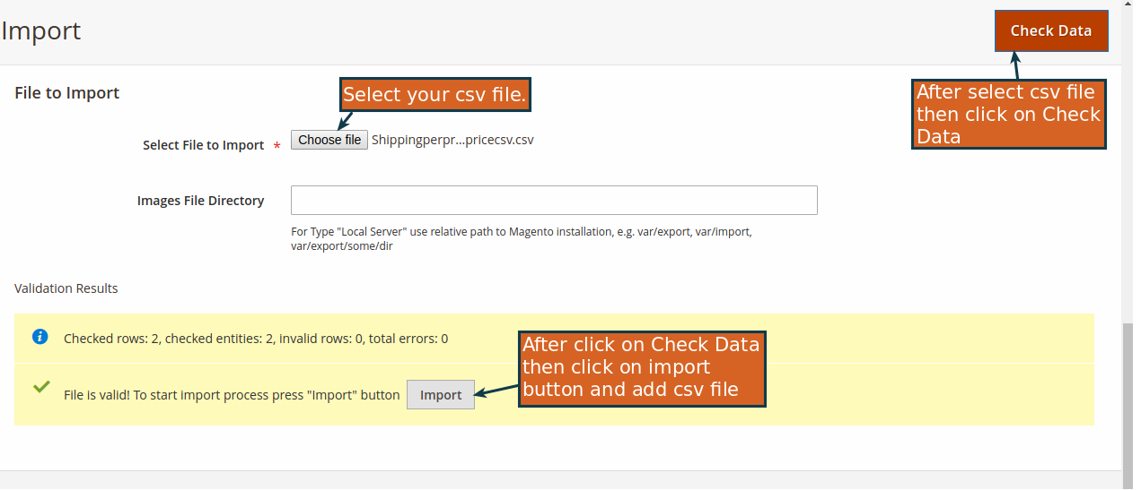

**Csv file description**

1) SKU – Enter product sku in sku field.

2) shipping_for_product – Enter price for shipping per product.

**Front End Example**

Select shipping per product method from car page.

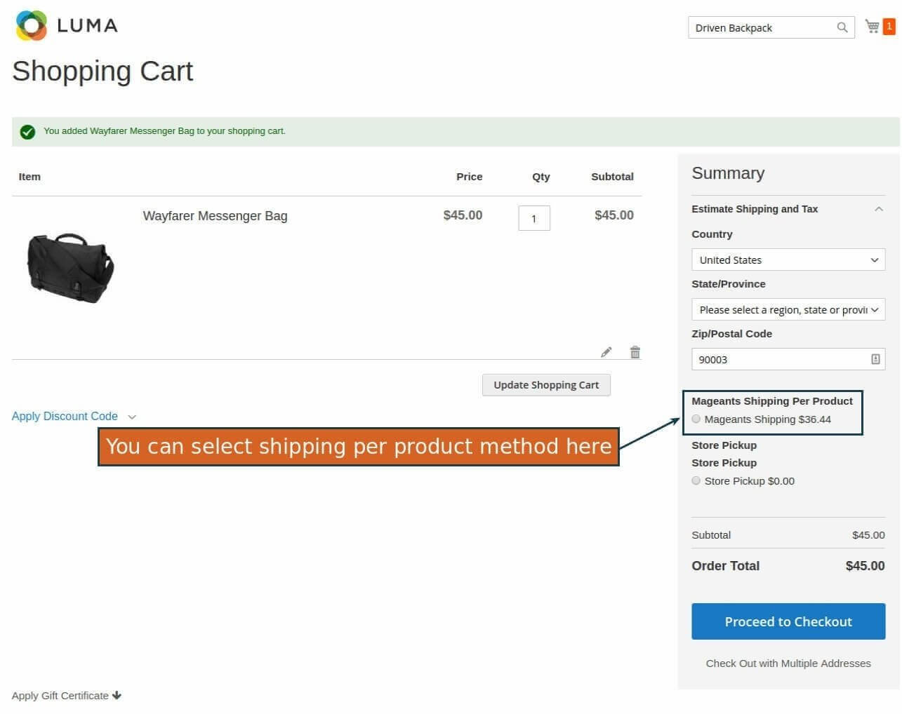

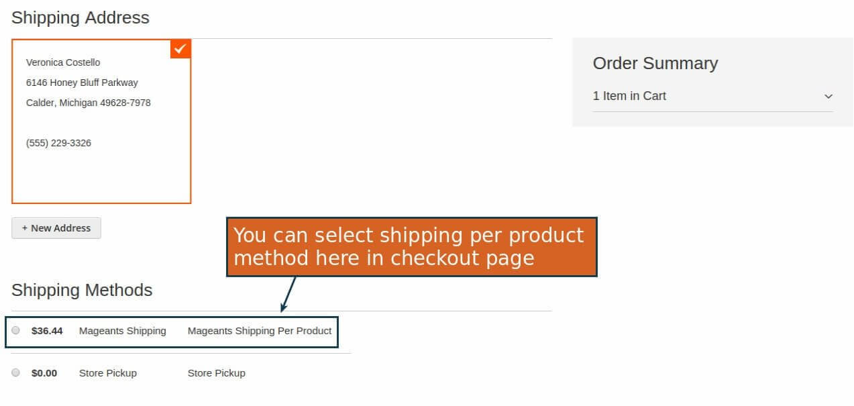

**Thank you!**

Should you have any questions or feature suggestions, please contact us at:

<https://www.mageants.com/contact-us.html>

Your feedback is absolutely welcome!